
‘GOING DIRECT’ - INTEGRATING THE NEW PARADIGM
Exploring the teachings of William Linville
FLAME RESIDENTIAL RETREAT IN NORFOLK
THURSDAY afternoon / evening Nov 26th SUNDAY afternoon Nov 29th 2015
William Linville is a truly remarkable being – it is said about him that he is “ a divine essence, clear Creator Consciousness in a physical body. He has ascended beyond all akashic records, perceptions of the truth, identifications, beliefs etc. which allows him to obtain clarity on any and all topics and so much more. William is here to assist you in accelerating and amplifying the process of you remembering, embodying and expanding into your Creator Essence and to experience all the possibilities that are available for you in a body on a planet.”

Last year’s retreat offered an introduction to William Linville’s work and an opportunity for all who came to dive straight into working with him over two phone sessions. This November we will be gathering again in an informal retreat at Rose Cottage, Sculthorpe, Norfolk to explore the theme of connecting up and ‘going direct’. Anyone is welcome, including those new to Will and those who are already familiar with his work.
William’s approach is direct and needs no interpretation, so why the workshop? Gathering together provides a forum where we can digest and assimilate the enormous scope and subtlety of what he transmits, amplified by the group process. In particular the retreat will be exploring how we ‘go direct’ to our ‘higher levels’, connecting with and expressing our divinity and the higher nature of our consciousness. The weekend workshop will include two live conference calls with Will, group discussion and personal work with reference to Will’s materials.
Please let us know as soon as you can if you would be interested to attend and if you know other people in the UK who might also be interested? If so please do pass this info onto them

SCHEDULE:
- Please arrive from 4pm on Thursday 26th Nov onwards.
- Please let us know well in advance If you need to be collected from Kings Lynn Station which is about 20 miles away - we will do one pick up and you will need to arrive at the station at around 2.30 pm
- The evening meal on Thursday 26th is at 6 pm
- The first evening session takes place from 7pm to 9pm on Thursday evening.
- As well as listening to and discussing the teachings during the time we spend together, we will also have fun enjoying nice food, meditation, amazing walks on the beach and sitting by log fires, and everyone takes their turn to help in the kitchen.
- The retreat finishes after lunch at 2.30 – 3 ish pm on Sunday.

COSTS:
- £200 ( early bird, fees to be received by October 21st) or full fee (£225, fees paid by Nov 7th) This includes all meals from Thursday evening to Sunday lunchtime and the costs of the calls with William Linville.
- Accommodation:
  - People will need to book their own Bed and Breakfast separately at an additional cost ( see below for some suggestions).
  - Accommodation at Rose Cottage is also available and will be allocated to those who can least afford to pay for B & B separately (there are 2 double bedrooms, a single, and sofa bed in the sitting room for anyone who doesn’t mind. )
  - Camper vans are also a possibility!
  - If you wish to come on this retreat but might have difficulties, please contact us to discuss this as concessions are available and payment by monthly instalment is also possible.
BOOKING: The retreat can take a maximum of 10 people and places will be allocated on a first come first served basis.
IF YOU ARE INTERESTED TO BOOK please email Ruthie to let her know you are planning to attend so we know about numbers and: -
- fill in the enclosed booking form and return by email to ruthie@ruthie.efsmith@gmail.com
- or print out and post to: to William Linville Retreat ,The Flame Centre, Unit 3 D, 50 Westminster Bridge Rd, London SE1 7QY enclosing your cheque

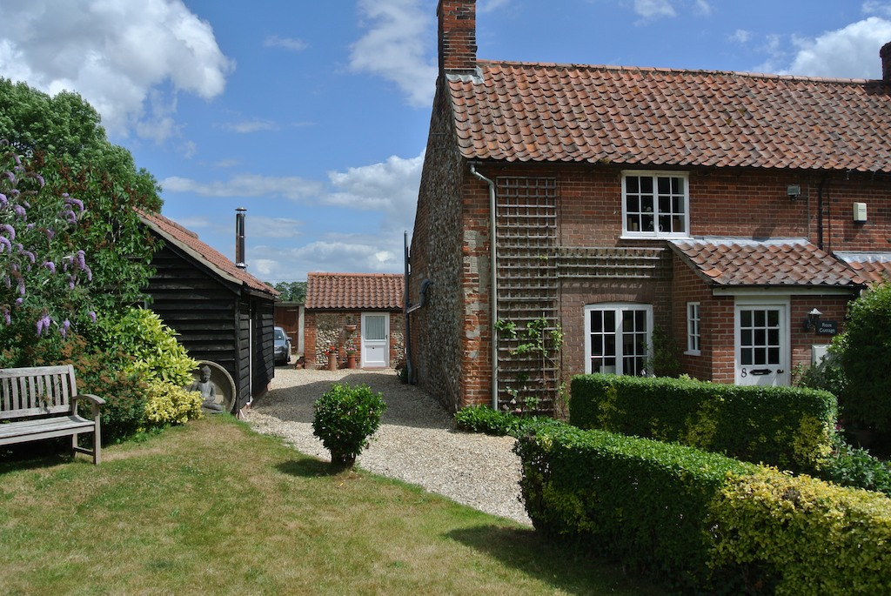
ABOVE: Rose Cottage, 8 Creak Road, Sculthorpe, Near Fakeham, Norfolk NR21 9NF

ACCOMMODATION:
Let us know if you would like to stay at Rose Cottage. Otherwise please book a local bed and breakfast:
- Manor Farm Bed & Breakfast Scuthorpe Fakenham Norfolk NR21 9NJ
stay@manorfarmbandb.com +44 (0) 1328 862185
- Erika’s bed and breakfast Fakenham 01328 863058
- Or you can also find other accommodation via the internet

TRAVEL: Rose Cottage 8 Creake Road Sculthorpe, Fakenham Norfolk NR21 9NF tel +44 1328 258438
Creake Road is situated off the A 148 about 20 miles from Kings Lynne. Rose Cottage, no 8 is quite close to the A 148 and can be recognized by the white farm gate and gravel drive. When driving from London (travel time varies depending on the time of day you travel and the traffic - it can take around 3 hours or 4 if you get caught in the rush hour). people usually take the M11, A 11/14 and then the A 1065 via Swafham. The A148 comes off the A1065 at the Fakenham roundabout.
- Most people drive here and it may be possible for people to share lifts – let us know if you are looking for a lift and we can put you in touch with others who are driving
- Otherwise , the nearest train station is Kings Lynn direct from Kings Cross – if you would like to be collected from the station (which is about 20 miles away) please let us know - you will need to book a train which arrives at around 2.30 ish on Thursday afternoon
- If you need to book a taxi from Kings Lynn it will be advisable to do this in advance

FACILITATORS: Simon Lofting and Ruthie Smith studied practiced and taught various aspects of meditation in the 80s and 90s . They discovered William in 2012 and have been indebted to him for his clarity and teachings and wanted to open a space for others also to come and share. They found their previous meditation a good foundation in relating to the very pure direct guidance offered by William Linville, who facilitates people awakening into their higher ‘creator’ consciousness.
We look forward to hearing from you
Namaste
Ruthie Smith & Simon Lofting

www.theflamecentre.co.uk

